n8n Setup Guide
Agentic AI Risk Assessment Lab

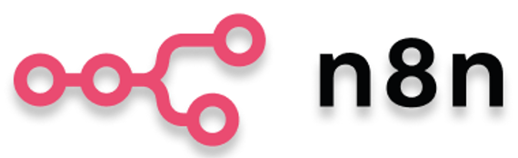

What is n8n and Why Are We Using It in This Lab?
n8n is a visual workflow automation platform that allows you to connect data, applications, business rules, and AI models into one automated process. Instead of building a complete software application from scratch, you can create workflows by connecting nodes that perform tasks such as receiving files, preparing data, calling AI models, and generating outputs.
In this lab, n8n is used as the automation and orchestration platform for the banking risk-review process. It helps bring together customer data, transaction data, risk rules, AI Agents, and reporting steps into one visible workflow.
For example, when a customer activity is flagged for review, the workflow can:
Collect Data → Prepare Data → Run AI Risk Assessment → Generate Structured Result → Send Higher-Risk Cases for Human Review
This shows how AI can be embedded into a real business process rather than used only as a standalone chatbot.
You need an n8n account because the lab workflow will be built, configured, tested, and executed inside the n8n workspace.
Think of n8n as the workspace where the complete AI automation solution is designed and run.

n8n Cloud Setup

Step 1: Open the n8n Website
- Goto https://app.n8n.cloud/login
- Open the n8n website in your browser.
- Click Get started for free to begin creating your n8n Cloud account.
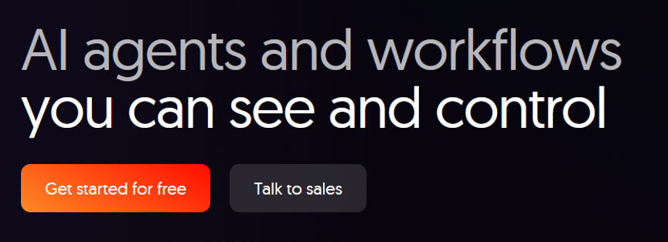

Step 2: Enter Your Email Address
- Enter your company or university email address in the Company email field.
- Click Submit.
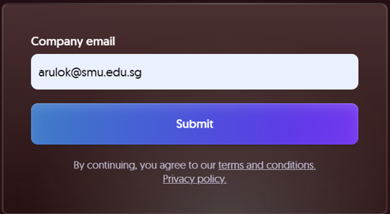

Step 3: Verify Your Email
- Check your email inbox for the verification message from n8n.
- Click the verification link or enter the verification code shown in the email, then click Submit.
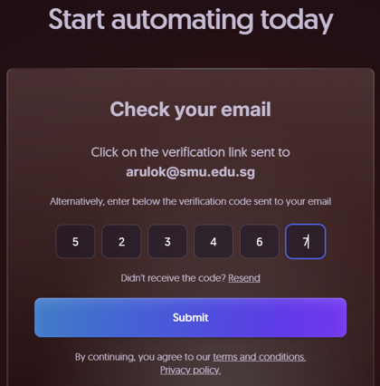

Step 4: Complete Your Account Details
- Enter your full name and create a password.
- Enter an account name for your n8n Cloud workspace.
- Complete the verification check if shown, then click Start free 14-day trial.
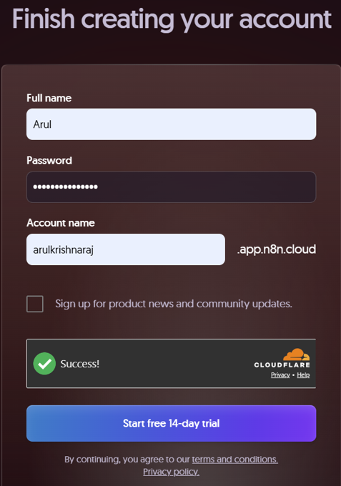

Step 5: Complete the n8n Onboarding Questions
- Answer the onboarding questions using the options that best describe you.
- Click OK or continue to the next question.
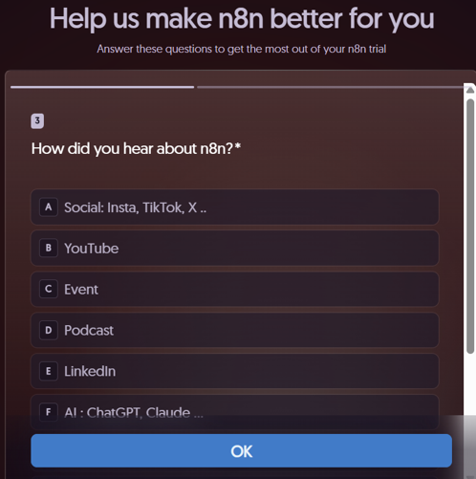

Step 6: Continue Through the Onboarding
- If you are asked Do you know what to automate?, you may select No and continue.
- These onboarding answers do not affect the lab workflow.
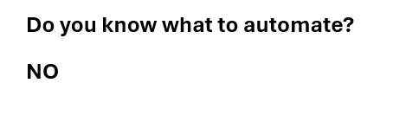

Step 7: Access Your n8n Workspace
- n8n may send you a welcome email after account creation.
- Use the Build your first workflow link if needed to open your workspace.
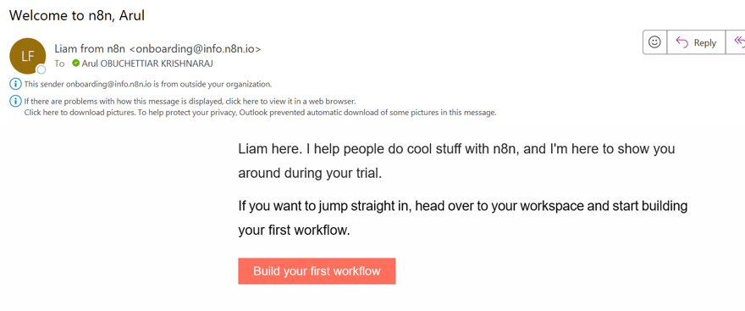

Step 8: Sign in to n8n
- If prompted, enter your registered email address and password.
- Click Sign in.
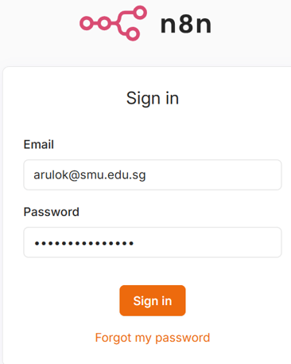

Step 9: Create a New Workflow
- In the n8n workspace, click the + icon in the upper-left corner.
- Select New workflow.
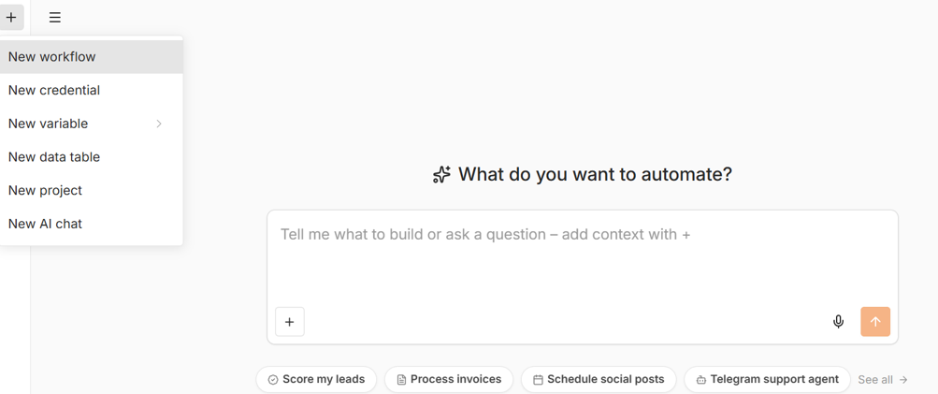

Step 10: Start Building the Workflow
- A blank workflow canvas will open.
- Click Add first step to build the workflow manually for this lab.
- You are now ready to begin Task 1 - Configure the Agent-1 File Upload Form.

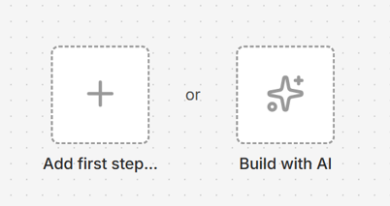

Expected Output
At the end of this setup, you should have an active n8n Cloud account, access to your workspace, and a new blank workflow ready for the lab.

